**Bright Light Therapy and Seasonal Affective Disorder**

**Elia Vecchione, PhD.**

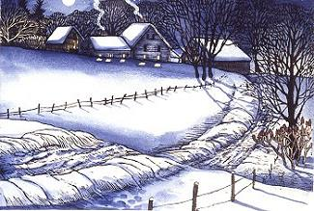

|  |
| --- |
| **Introduction**  What follows is an overview of bright light therapy and its effectiveness in treating Seasonal Affective Disorder (SAD). The prologue provides a story that shows how easy it is to miss the diagnosis and the details of providing treatment. Following that is an overview of diagnostics and treatment in greater detail, including research references. The frequently asked questions, as one would suspect, is a summary of frequently asked questions. The summary section puts all the information for seasonal depression and Bright Light Therapy in table form. The epilogue is a parting story that occurred at the end of writing this piece, followed by references and other readings, and sources for lights. Addendum A includes changes in thyroid function that may contribute to seasonal changes in behavior. Jump around or ahead to any portion you like, but get those lights turned on soon! |
| **Prologue** |

I talked to a mother mid-October last year. She wanted some advice on medication. She told me that her son had been put on Prozac. She also said that since the medication started, he had been more tired during the day. She wondered if splitting the dose or changing the time the medication was given might improve his attention and energy level during the day.

I asked her why her son had been put on the medication. She told me that she wasn't exactly sure. She had taken him to his physician because, “he didn't seem to be himself.” He wasn't very happy, and he was tired and irritable. The doctor had not given the mom a diagnosis, but prescribed a medication that’s typically used to treat depression. At the time, the boy was nine years old. (The research does not support the use of antidepressants with children that young. See the question and answer section.)

Although he had been on the medication for over a month, the typical time it takes to show improvement with these medications, his symptoms had actually gotten worse. He was hard to get up in the morning, falling asleep during the day, having trouble at school, and rarely, if ever, smiled. I will remind you that it was mid-October in Vermont. The sun was in full retreat and the skies were mostly cloudy. The trees were no longer green, but red and brown and yellow. They were also feeling the effects of the reduced sunlight.

The next question I asked seemed obvious to me, given the time of year and the symptoms that the boy was displaying. I asked about his sleep. She said it seemed fine, other than that he seemed to procrastinate a lot before bed and was terribly difficult to wake up in the morning. She said that some mornings she had to practically drag him out of bed. I asked if he had been getting up during the night more than usual. She told me that he was waking up and eating in the middle of the night, something he had never done before.

“I guess his sleep is a mess.” She said.

Although the sleep difficulties weren’t obvious to his mom at first, he was having a harder time getting to sleep, difficulty staying asleep, and a real challenge getting up on time.

When we considered sleep disturbance, the time of year, and all the other symptoms (irritability, sadness, carbohydrate craving, brain fog), it seemed like an obvious diagnosis. I asked mom if she had been told about Seasonal Affective Disorder. I asked if it was ever mentioned as a possible cause for the problems her son was having. She said it had not. I also asked if her physician had offered any other treatments aside from medication. Unfortunately, he had not.

We then spent some time talking about SAD and the most benign and effective treatment, Bright Light Therapy. I explained that at this time of year, especially in places like Vermont, we could expect the symptoms her son was experiencing to emerge in over 20% of people. The symptoms are related to the changes in the intensity and duration of sunlight. The best way to improve the symptoms, and help her son with his behavior, was exposure to bright light, more commonly known as Bright Light Therapy.

Back in 1993, the American Psychiatric Association recommended Bright Light Therapy as the treatment for SAD. Research has shown that it is the quickest and most effective treatment for SAD (sometimes also referred to as Winter Depression) and has the fewest side effects. It has since been shown to be effective with non-seasonal depression as well.

Anyway, she thought it was worth a try, particularly because she was concerned about her son being on medication. I loaned her a light therapy lamp that we happened to have at the office. I told her that her son needed a full half hour of exposure to this light soon after he got out of bed in the morning. She said that she didn't believe her nine-year-old would sit still for that amount of time. So we discussed his morning routine. It had been more difficult to get him out of bed recently, so the morning routine was generally rushed. However, he did spend some time at the table having his breakfast and watching some TV.

I asked her to set the light up next to the table so that he could be exposed to it while he had his breakfast and watched his cartoons. We also talked about coming up with an explanation for him about why he needed to be exposed to the light. Mom could explain to him the great reduction in the light between summer and fall. We decided to call the morning light routine “getting summer sun.”

A couple of pretty amazing things happened. First of all, with the proper explanation, her son tolerated the lights very well. He actually looked forward to his little burst of summer sun each morning. On the first morning, when he did his routine under the lights, his mom went off to get ready for work. When she returned, at the end of his breakfast and light session, he looked up at her with a big bright smile. The mother later told me that she almost burst into tears. She realized that she hadn't seen that smile for quite some time. Later that same day the woman got an email from the boy’s school. His teacher just wanted her to know what a wonderful day her boy had at school. The teacher also wondered if something had happened at home that improved his mood and behavior so dramatically. Indeed something had happened. (There is actually a study in which the researchers found a significant decrease in depressive symptoms after a single session of Bright Light Therapy. See Reeves et al, 2012.)

Although this is a remarkable story, I want to stress that the course of treatment for SAD and depression is not one session. In order to get the best results, Bright Light Therapy should be done daily, at about the same time, for about two weeks. It should then be continued for the entire winter season to maintain the benefit. (See the full set of recommendations at the end of this chapter.)

**Overview of Bright Light Therapy and Seasonal Affective Disorder**



*“Whoever wishes to investigate medicine should proceed in the first place thus: Consider the seasons of the year.”*  
 -Hippocrates: On Airs, Waters, and Places

Seasonal depression has become a significant problem since the invention of the light bulb. In this day and age, our vocational and interpersonal commitments have made it necessary to ignore our internal clocks. If you lived in Vermont a hundred or so years ago you would have probably been a farmer and followed the same routine as your crops and animals. Summer days would have been long and full of hard work, mostly spent outdoors. Winter days would have been shorter and involved a lot of sitting by the woodstove, snoozing. There are lots of physiological changes that underlie these behavioral changes. (Think hibernating bears.)

For some examples of these changes, we can look to a study of Seasonal Depression by Reed and his colleagues (2001). In the study, which took place in Antarctic over the course of the winter, subjects suffered a dramatic decrease in thyroid hormone. The symptoms that the patients suffered included lack of energy, brain fog, and sleep disturbance. The depressive symptoms were reversed when the patients were treated with thyroid hormone. (See Addendum A for more information on seasonal effects on thyroid.)

SAD is “latitude dependent” and quite prominent in places where the seasonal variations in light are the greatest. The farther we go north, the less light there is and the more dramatic the changes in the light. Days are much shorter and there’s much less sunlight in the winter. If you went as far north as Alaska you would find the rates of SAD as high as 45%.

In Burlington (Vermont) there are, on average, over 200 days per year when there isn’t enough sunlight to make Vitamin D, which means a lot less sunlight than we need to reset our internal clocks. Our internal clocks don’t run 24 hours like you might think. The clocks run more like 25 hours, and need to be reset every day to match our “social clock.” Since our sleep is based on our internal clock and not our social one, this means lots of sleep problems. Translation: lots of tired, cranky people.

Sleep can be affected in many different ways. There can be difficulties getting to sleep, staying asleep, and waking up. There is also hypersomnia, which is extended sleep without achieving a feeling of rest. Sleep disturbances can quickly lead to disturbances in mood and behavior. What typically happens in SAD is that the sleep cycle shifts either forward (earlier), or backward (later).



*“Phase Delayed” internal clocks shift forward, making it hard to get to sleep and hard to get up. This is typical of younger people. “Phase Advanced” internal clocks shift backward and make people tired earlier so these people go to bed earlier and get up earlier. This is typical of older people.*

In the “Phase Delayed” shift, people have a hard time getting to sleep and getting up, when the social clock tells them they should. Young people are most likely to suffer from this problem. So, for example, if a high school student needs to be up at 7 AM to be at school on time, she probably needs to be in bed by about 11 PM in order to get the necessary amount of sleep. Let’s say her internal clock shifts forward a few hours. Well, then she won’t be able to get to sleep until about 1 AM. When she needs to get up at 7AM, she will have only had 6 hours sleep and will be most likely be tired, groggy, and not perform very well at school. The problem can then be compounded over time as her internal clock continues to shift forward, and we can expect increased irritability, decreased attention and concentration, and changes in behavior, generally not for the better.

An additional problem is that more likely than not, she will fill the time she should be sleeping (from 11pm to 1am) with TV, video games, or texting. The shift in her clock could easily be overlooked as the source of her inability to get to sleep, and the subsequent tiredness and behavioral challenges. The social and other media will more likely than not be blamed for the sleep disturbance rather than the shift in sleep cycle. If parents decide media is the problem and take it away, it won’t correct the sleep problem. What it will do is frustrate the young person who can’t sleep.

In Vermont, we can expect about 22% of people to be clinically affected by the lack of sun. However, everyone feels it to some degree, even if it doesn’t interfere with their lives. This means more irritability, less energy, brain fog, and other depressive symptoms. Are you craving potato chips, home fries, and candy bars? Can’t remember where you put those keys, or what time your meeting is? Are you tired, even when you feel you’ve had plenty of sleep? Just don’t feel like doing the things you usually enjoy? Are things that don’t usually bother you really getting under your skin? Yell at anyone lately? Do you live in Vermont or in the northern latitudes?

You may be feeling the same way the trees are, losing your leaves and shutting down for the winter. You may be reacting to the lack of sunlight. You could be suffering from “the Winter Blues”, or even have a case of SAD.

In populations that already suffer from increased rates of mental health, behavioral, and emotional problems, the incidences of SAD is likely to be much greater. We can expect people who receive mental health and other related services to have a more severe reaction to the seasonal changes in light and temperature. Often these people have comorbid disorders including non-seasonal depression, Bipolar Disorder, Bulimia Nervosa, Attention Deficit Disorder, PMS, and sleep-wake disorders. These also respond to Bright Light Therapy. This would at least suggest that they might share some basic etiology.

Here at the Francis Foundation, we serve adults and young people with social, emotional, and behavioral challenges. A few years ago, when we looked at the number of incident reports (these document behavioral incidents) turned in each month, we found significant increases in behavioral difficulties during the months of October and November and also during April and May. These months are during the times of the year when the most dramatic changes in light and temperature occur. It makes sense that the greatest behavioral challenges tend to happen around these times.

The typical pattern of behavioral changes includes both a fall and a winter component. The fall pattern has a depressive profile, which includes irritability, “brain fog”, lack of energy and initiative, and appetite and sleep problems. (See symptom list in summary section.) The spring component looks quite different and has a manic profile. The spring symptoms can be extremely challenging and can often result in mania, which includes very high levels of activity and very little sleep, and for the least fortunate, out-of-control behavior. March Madness is not just about basketball.

If we utilize Bright Light Therapy and other treatments, then we can avoid the Winter Depression. It seems that managing the Winter Depression is the key to managing the spring mania that can lead to such major behavioral problems.

So, if you manage the Winter Depression, with Bright Light Therapy, you won’t get the spring mania. Get those lights out!



*The changes in light from full summer sun to diminished winter sun*

*parallel the changes in mood and rates of depression.*

*Source: Winter Blues, Dr. Norman Rosenthal, 2006*

**Frequently Asked Questions**

*So what can we do about it?*

The American Psychiatric Association recommended Bright Light Therapy to deal with the problem about 20 years ago (1993). They recommended exposure to very bright white light (not full spectrum), of at least 10,000 lux, or lumens, for at least a half hour per day. Generally, this should happen first thing in the morning, within a half hour or so of waking up. For some people, later in the day is better. It depends upon the direction that the internal clock shifted. The exact timing should be decided with the assistance of a clinician who has experience with Bright Light Therapy.

It is recommended that light exposure is done daily for at least two weeks, and that it should be maintained for the entire season at least five times per week. Exposure to the light can happen while eating breakfast, watching TV, or pecking away on our computers. It should fit into the person’s schedule and not interfere with it. The light should be just above the person and within 18 inches of his eyes. The person should continue with whatever his activity happens to be and he shouldn’t look directly at the light.

How effective is Bright Light Therapy?

It is very effective and has few or no side effects. There are a number of studies that document the effectiveness of Bright Light Therapy. Some of the most comprehensive of these studies are known as meta-analytic studies (studies of studies). Using this method, the information from many studies are put together and analyzed as a group. One such meta-analysis reported that, “analysis of randomized, controlled trials suggests that bright light treatment and dawn simulation for Seasonal Affective Disorder and bright light for nonseasonal depression are efficacious, with effect sizes equivalent to those in most antidepressant pharmacotherapy trials” (Golden et al., 2005). So, for seasonal depression, AND typical, non-seasonal depression, Bright Light Therapy is as effective as medication.

How effective is it compared to medicine?

One study from Canada looked at the effectiveness of Bright Light Therapy compared to a popular anti-depressant. Patients responded to the light treatment faster than the medication! At the end of the study, the investigators determined that the light treatment was as effective as medication without any of the side effects. (Lam et al, 2006)

How about side effects of medication and light therapy?

The side effects of medication can include sleep disturbance, autonomic side effects such as dry mouth and sweating, and central nervous system effects like headache, sedation, and dizziness. They can also include weight gain or loss, gastrointestinal effects such as diarrhea and constipation, and behavioral effects such as agitation, anxiety, and fatigue, as well as sexual side effects (Ferguson, 2003). One study of side effects of Bright Light Therapy found that “several side effects emerged--mostly mildly--including jumpiness/jitteriness, headache, and nausea. In most cases, remission rate equaled or exceeded emergence rate” (Terman et al, 1999). In other words, the side effects went away quicker than they emerged. So for Bright Light Therapy the side effects were much more limited, and much milder, than the side effects of medication. They were also easily reversible by modifying the light schedule.

How expensive is it?

It is quite a bit less expensive than taking medication. Once people begin taking medication for depression they are typically on that medication for years. So it is the cost of the medication times the number of days it is taken. A typical medication for depression mentioned earlier is Prozac. That medication at a local pharmacy, here in Waterbury, Vermont, costs 60 cents per day or about $220 per year. A light therapy lamp, that produces at least 10,000 lumens of light can be purchased for about $200 or less, and should last many years. There are many therapy lights now available under $100. (See sources in summary section.) The more industrious among us can make an effective, if not pretty, light for about $30 out of 2 shop-lights equipped with bright white bulbs.

Are antidepressants safe to use with children?

In our opening vignette a nine year old was given Prozac without considering alternative treatments. There has been a great deal of controversy about the use of antidepressants with children, in part because it hasn’t been well researched. There has also been a great deal of concern about antidepressants leading to suicidal ideation and behavior in children.

A recent meta-analysis of the effectiveness of antidepressants with children concludes, “Antidepressants of all types showed limited efficacy in juvenile depression” ([Tsapakis](http://bjp.rcpsych.org/search?author1=Evangelia+M.+Tsapakis&sortspec=date&submit=Submit) et al, 2008). In a study by Jureidini and his colleagues, investigators' conclude that “the efficacy of newer antidepressants in childhood depression have exaggerated their benefits. Benefit from the drugs is of doubtful clinical significance and adverse effects have been downplayed. *Antidepressant drugs cannot confidently be recommended as a treatment option for childhood depression.”*

And finally, if Bright Light Therapy is so great, why isn’t it recommended by ALL physicians?

Great question. It is safer, faster, and proven to be effective for seasonal and non-seasonal depression. It should be the first line of defense for seasonal depression and maybe non-seasonal as well. The reason that it isn’t recommended may have to do with a couple of things. Clearly, in order to help people see the value in it, and motivate them to try a course of treatment, they need the basic information about Bright Light Therapy (such as what’s contained in this chapter). An average physician’s appointment lasts less than 8 minutes. Perhaps there just isn’t enough time to explain it to patients. The other possible explanation is that many, if not most, physicians are just not familiar with alternatives to medication, including Bright Light Therapy.

______________________________________________________________

**Summary**

______________________________________________________________

**Symptom List:**

Typical Symptoms of Depression (of which SAD is a sub-type):

1. Loss of energy
2. Social withdrawal
3. Sleep disturbance (increased or decreased)
4. Loss of interest in activities you once enjoyed
5. Changes in appetite (increased or decreased)
6. Weight gain or loss
7. Difficulty concentrating
8. Irritability and agitation
9. Hopelessness
10. Anxiety

Typical Symptoms of Seasonal Affective Disorder:

1. Increased rather than decreased sleep

2. Difficulty waking

3. Daytime fatigue

4. Increased rather than decreased appetite and food intake

5. Carbohydrate craving

6. Marked increase in weight

5. Irritability

6. Interpersonal difficulties (especially rejection)

7. Leaden feeling limbs

According to the Diagnostic and Statistical Manual of Mental Disorders, SAD is a subtype of Depression. People suffering from SAD may have some or many of the typical symptoms of depression. However, their symptoms are usually in the direction of more sleep, greater food intake, weight gain, and carbohydrate craving.

______________________________________________________________

**Seasonal Changes in Light:**

______________________________________________________________

Day Length: Summer: 14 hours

Winter: 8 hours

Light Intensity: Full Summer Sunlight: 100,000 lux

Winter Overcast: 10,000 lux

Bright Interior Light: 2,000 lux

Dim Interior Light: 200 lux

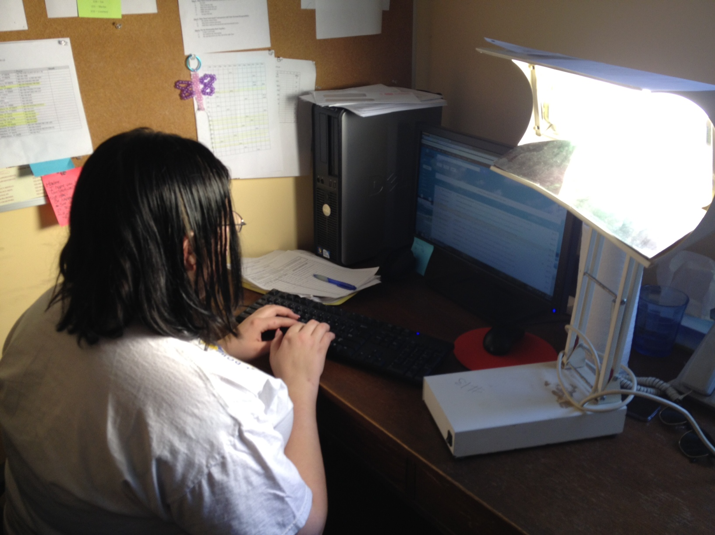 There is about a 99.5% reduction in light exposure from full summer light to interior winter light. The reduction in day length, the fact that people, at least in the Northeast, spend a great deal more time outdoors in the summer and inside in the winter, and the reduction in available sunlight, accounts for the dramatic decrease in light exposure

Intensity: 10,000 lumens

**Treatment Parameters for Bright Light Therapy**

______________________________________________________________

Duration: 30-60 minutes

Time of Day: Morning for Phase Advanced

Evening for Phase Delayed

Wavelength: Bright WHITE light (not full spectrum)

Position: Above eyes and within 18 inches

Response Time: 5 days to 2 weeks

Treatment Duration: Entire season

Modified Schedule: 5 times per week

Caveat: Bright Light Therapy treatment should be monitored and adjusted with the assistance of a clinician who is knowledgeable and experienced in supervising this kind of therapy.

______________________________________________________________

**Epilogue**

**_____________________________________________________**

As I was writing the symptom section on SAD, a young lady came to see me. Once again, it is mid-October in Vermont. The past week had been very sunny and warm, and the past three days have been dark and gloomy. It almost seems as if the day has forgotten to come.

I saw her last week and she looked and felt fine. Today she looked exhausted. I asked her how she was feeling and she said terrible. She started to tell me about the past few days in a rather disorganized way. She said that her memory was not working very well and that she “couldn’t think straight.” So we got out a flip chart and mapped out the past 24 hours. The visual aid helped, certainly in part because it diminished her need for working memory to retain information. What we “discovered” was that she had slept 21 of the past 24 hours! She really had only gotten out of bed for food and the bathroom.

In addition to the prolonged periods of non-restorative sleep (more on that in a moment), she reported that she is tired, confused, has no energy, and doesn’t feel like doing any of the things she normally enjoys. It is often confusing for a person when she has had lots of sleep and is still tired. The reason is that the sleep cycle is disturbed and even though she is asleep, the normal sleep rhythm is off and she is not getting rest. Getting too much sleep can be just as much a problem as getting too little sleep.



*Increased sleeping without feeling rested is known as hypersomnia and is a typical symptom of seasonal affective disorder. Although there is increased sleep it is non-restorative and has a different “sleep architecture” than normal restorative sleep. Most importantly, despite the increased sleep, people are still tired.*

She was also quite concerned that she was feeling this way because she had missed a dose of her medication. So we spent a little time looking out the window and talking about the changes in the trees. We then spent some time talking about the changes in the available sunlight that triggered the changes in the trees. We agreed that the past three days had been dark and gloomy and that her symptoms were most likely related to the quick change in available sunlight.

I told her it always surprises me how fast the seasonal effect of less light can occur.

Once we were both on the same page about the cause of her symptoms, the course was clear. Bright Light Therapy. We found a light, alerted her care taker to the need and proper use of the light, and they were off. We also decided that she was usually up around 7 AM and that was a good time for the both of them to sit, have coffee, talk, and expose themselves (themselves, not her) to the light.

**References**

Ferguson, J. (2001). SSRI antidepressant medications: Adverse effects and

tolerability, primary care companion. *The Journal of Clinical Psychiatry 3*(1),

22-27.

Golden, R. (2005). The Efficacy of light therapy in the treatment of mood

disorders: A review and meta-analysis of the evidence. *Am J Psychiatry*, *162*,

656-662.

Jureidini et al, (2004). Efficacy and safety of antidepressants for children and

adolescents. *British Medical Journal, 328*(7444), 879-883.

Lam, et al. (2006). The Can-SAD study: A randomized controlled trial of the

effectiveness of light therapy and fluoxetine in patients with winter

seasonal affective disorder. *The American Journal of Psychiatry*, *163,* 805-812.

Reed et al., (2001). Impairment in cognition and exercise performance during

prolonged Antarctic residence: Effect of thyroxine supplementation in the polar T3 syndrome. *Journal of Clinical Endocrinology & Metabolism*, *86,* 110-116.

Reeves, J. et al., (2012). Improvement in depression scores after 1 hour of light

therapy treatment in patients with SAD. *Journal of Nervous and Mental*

*Disease, 200*(1), 51-55.

Terman M., Terman, J.S., (1999). Bright light therapy: Side effects and benefits

across the symptom spectrum. *Journal of Clinical Psychiatry, 60*, 799–808.

[Tsapakis](http://bjp.rcpsych.org/search?author1=Evangelia+M.+Tsapakis&sortspec=date&submit=Submit), E.M., Soldani, F., Tondo, L. & Baldessarini, R.J., (2008) Efficacy of

antidepressants in juvenile depression: Meta-analysis. *British Journal of Psychiatry, 193*(1), 10-17.

**Suggested readings:**

1. Rosenthal, Norman “Winter Blues”
2. Lam, Raymond “Seasonal Affective Disorder and Beyond”
3. Lam, R., Tam, E., “A Clinician’s Guide to Using Light Therapy”
4. Partonen, T., Pandi-Perumal, S.R., “Seasonal affective Disorder: Practice and Research”

**Sources for Bright Light Therapy lights:**

1. Northern Lights Technology, Montreal CA

northernlightstechnology.com

2. Verilux, Inc., Waitsfield VT

Verilux.com or 1-802-496-3101

3. Amazon.com for multiple sources